A. Pizza Bite Crunchers
B. Boneless Chicken Wings w/Cheese Crackers
Baked Beans

A. Cheese Omelet w/Vanilla Goldfish Cracker
B. Deluxe Nachos
Cooked Carrots

A. Chicken Nuggets w/Dinner Roll
B. Cheese Quesadilla
Steamed Broccoli

A. Cheese Stuffed Breadsticks
B. Pancakes w/Sausage Patties
Ckd. Green Beans

No School
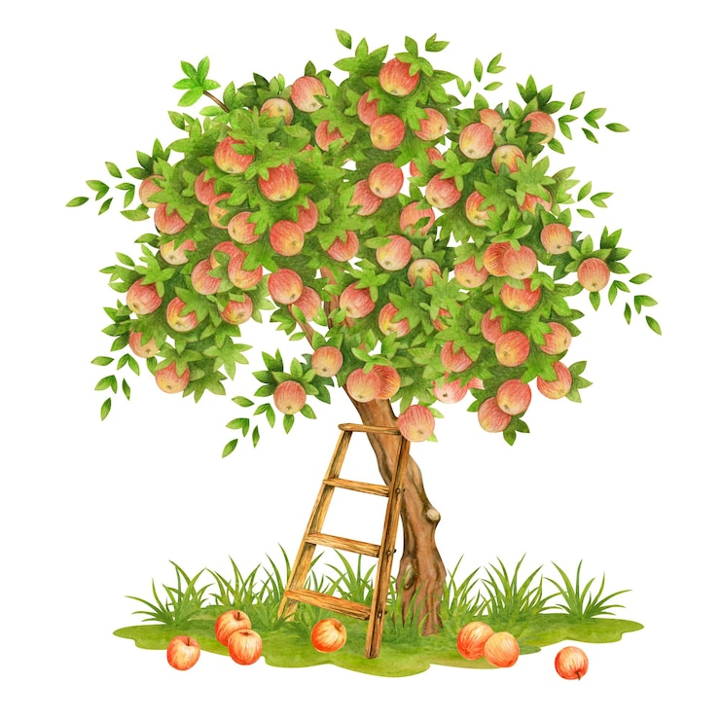
A. Chicken Strips w/Cheese Crackers
B. Bacon Egg & Cheese Bagel Sandwich
Baked Beans

A. Cheese Omelet w/Vanilla Goldfish Cracker
B. Soft Shell Taco
Sweet Potato Tots

A. Mini Corn Dogs
B. Chicken Nuggets w/Dinner Roll
Steamed Broccoli

A. Chicken Leg w/Mash. Potatoes & Dinner Roll
B. Turkey/Cheese Sub
Cooked Green Beans

A. Chicken Fried Rice w/Fortune Cookie
B. Pepperoni Pizza
Cooked Garden Corn

Enter Text Here
A. Chicken Leg w/Mashed Potatoes & Dinner Roll
B. Cheese Stuffed Breadsticks
Baked Beans

A. Soft Shell Taco
B. Soft Pretzel Wrapped Hot Dog
Cooked Carrots

Did you know???

October is National Pizza Month
Random fact…

Illinois is the largest grower of pumpkins in the United States.
World Smile Day


Hamilton Elementary Schools

News
Meals are free through 9/30/2025.
More details soon.
*Included daily with lunch will be several of the following choices of fruit. Fresh Apples & Oranges. Canned in juice Applesauce, Peaches, Pears, and Pineapple. 100% Apple, Orange & Grape Juice.
Vegetable Choices.
In addition to the daily hot choice are the following, Fresh Baby Carrots, Celery and Broccoli.
Also 1% White or Fat Free Chocolate Milk. All breads and breading’s are whole grain.
We serve free breakfast every day in the cafeteria before school through 9/30/25
This institution is an equal opportunity provider

Labor Day

A. Soft Shell Taco
B. Hot Dog
Cooked Carrots

A. Mini Corn Dogs
B. Chicken Nuggets w/Dinner Roll
Steamed Broccoli

A. Apple Cinnamon French Toast w/Sausage Patties
B. Chick Fries w/BBQ Sauce
Ckd. Green Beans

A. Cheeseburger
B. Tony’s Round Cheese Pizza
Cooked Sweet Peas

A. Pepperoni Pizza Pocket
B. Breaded Chicken Sandwich
Baked Beans

A. Italian Pull Apart Cheese & Garlic Bread w/Dip. Sauce
B. Deluxe Nachos
Sweet Potato Tots

A. Chicken Nuggets w/Dinner Roll
B. Straw. Ban. Yogurt w/ Warm Cinn. Pretzel Stick
Steamed Broccoli

A. Cheeseburger
B. Pancakes w/Sausage Patties
Cooked Green Beans
Fruit Slushie

A. Hot Dog
B. Tony’s Round Cheese Pizza
Cooked Garden Corn

