
Hamilton Middle School
Prices

Breakfast Free
Lunch Free
May/June
26  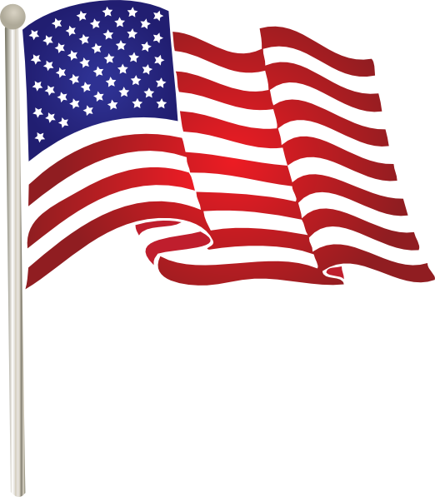Memorial Day | 27  *Pulled Pork Sandwich  *Sausage Egg & Cheese Bagel Sandwich  Baked Beans | 28  *Chicken Bacon Sandwich  *Cheese Stuffed Breadsticks w/Dipping Sauce  Cooked Green Beans | 29  *Deluxe Nachos  *Hot Dogs  *Pizza Pocket  Fresh Broccoli | 30  *Ham & Cheese Calzone  *Corn Dog  *Chicken Nuggets w/Crackers  Cooked Garden Corn
02  *Beef/Bean & Cheese Burrito  *Chicken Tenders w/Cheese Crackers  *Pepperoni Pizza Pocket  *Egg Rolls  Cooked Garden Corn | 03  *Soft Shell Tacos  *Breaded Chicken Sandwich  Baked Beans | 04  *Chicken Bacon Sandwich  *Apple Cinnamon French Toast w/Sausage Patties  *Cheese Stuffed Breadsticks w/Dipping Sauce  Cooked Green Beans | 05  *Beef Taco Sticks  *Deluxe Nachos  *Mini Corn Dogs  Fresh Broccoli | 06  Half Day  Last Day of School  
09 | 10 | 11 | 12 | 13
16 | 17 | 18 | 19 | 20
23 | 24 | 25 | 26 | 27
Have
A
Great
Summer
Vacation
See
You
In
August

MONDAY TUESDAY WEDNESDAY THURSDAY FRIDAY

Monday Tuesday Wednesday Thursday Friday
Mini Pancakes | Choc. Chunk Benefit Bar | Whole Grain Mini Cinnamon Rolls | Whole Grain Apple or Cherry Frudels | Choc. Chip French Toast

Daily Breakfast Entrées Include: 100% Asst. Fruit Juices, Fresh and Asst.Canned Fruit.
1% White and Skim Chocolate Milk (Cereal Kits also available daily)

Available Daily
*Hamburgers/*Cheeseburgers/*Chef Salads
*Turkey & Cheese Sub Sandwiches/*Cheese & Pepperoni Pizza Hut Pizza

Due to product availability Menus are subject to change

*Included daily with lunch are several choices of fruit and vegetables.
Fruit Choices.
Apples, Oranges, Watermelon, and Grapes (seasonal), canned in juice, Peaches, Applesauce, Pears, Pineapple and Mandarin Oranges.
100% Apple, Orange and Grape Juice.
Vegetable Choices.
In addition to the daily hot choice, Fresh Baby Carrots, Celery and Broccoli.
Also 1% White and Fat Free Chocolate Milk.
*All breads and breading are whole grain.

This institution is an equal opportunity provider.
Breakfast
Breakfast Meal Deal
(1) Entrée Choice
(2) Fruit or Fruit Juice
(1) Low-Fat 1% or Skim Milk (8oz)

Lunch Meal Deal
(1) Entrée Choice (bread & protein)
(2) Fruit Choices
(2) Vegetable Choices
(1) Low-Fat 1% or Skim Milk (8oz)

