
Hamilton Middle School
Prices

Breakfast Free
Lunch Free
April/May
21  *Chicken Egg Rolls  *Chicken Tenders w/Cheese Crackers  *Pepperoni Pizza Pocket  Cooked Garden Corn | 22  *Soft Shell Tacos  *Breaded Chicken Sandwich  Baked Beans | 23  *Apple Cinnamon French Toast w/Sausage Patties  *Cheese Stuffed Breadsticks w/Dipping Sauce  Cooked Green Beans | 24  *Beef Taco Sticks  *Orange Chicken Stir Fry w/Rice & Fortune Cookie  *Mini Corn Dogs  Fresh Broccoli | 25  *Chicken Cheese Quesadilla  *Mozz. Cheese Sticks w/Dipping Sauce  *Ham & Cheese Calzone  Cooked Garden Corn
28  *Chicken Leg w/Mashed Potatoes & Dinner Roll  *Italian Pull Apart Cheese & Garlic Bread w/Dipping Sauce  Cooked Garden Corn | 29  *Pulled Pork Sandwich  *Sausage Egg & Cheese Bagel Sandwich  Baked Beans | 30  *Chicken Bacon Sandwich  *Cheese Stuffed Breadsticks w/Dipping Sauce  Cooked Green Beans | 01  *Deluxe Nachos  *Hot Dogs  *Strawberry Parfait w/Cereal Bar  *Pizza Pocket  Fresh Broccoli | 02  *Ham & Cheese Calzone  *Corn Dog  *Chicken Nuggets w/Crackers  Cooked Garden Corn
05  *Beef/Bean & Cheese Burrito  *Breaded Mac & Cheese Bites  *Pepperoni Pizza Pocket  Cooked Garden Corn | 06  *Soft Shell Tacos  *Breaded Chicken Sandwich  Baked Beans | 07  *Apple Cinnamon French Toast w/Sausage Patties  *Cheese Stuffed Breadsticks w/Dipping Sauce  Cooked Green Beans | 08  Half Day   | 09  *Chicken Cheese Quesadilla  *Mozz. Cheese Sticks w/Dipping Sauce  *Ham & Cheese Calzone  Cooked Garden Corn
12  *Chicken Leg w/Mashed Potatoes & Dinner Roll  *Pizza Bite Crunchers  Cooked Garden Corn | 13  *Pulled Pork Sandwich  *Sausage Egg & Cheese Bagel Sandwich  Baked Beans | 14  *Chicken Bacon Sandwich  *Cheese Stuffed Breadsticks w/Dipping Sauce  Cooked Green Beans | 15  *Deluxe Nachos  *Hot Dogs  *Strawberry Parfait w/Cereal Bar  *Pizza Pocket  Fresh Broccoli | 16  *Ham & Cheese Calzone  *Corn Dog  *Chicken Nuggets w/Crackers  Cooked Garden Corn
19  *Chicken Egg Rolls  *Chicken Tenders w/Cheese Crackers  *Pepperoni Pizza Pocket  Cooked Garden Corn | 20  *Soft Shell Tacos  *Breaded Chicken Sandwich  Baked Beans  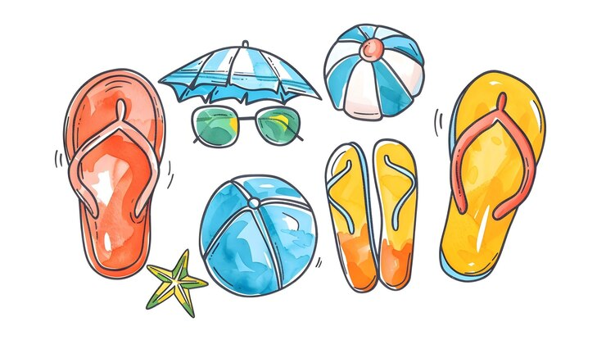 | 21  *Apple Cinnamon French Toast w/Sausage Patties  *Cheese Stuffed Breadsticks w/Dipping Sauce  Cooked Green Beans  Today is Eat More Fruits & Vegetables Day. | 22  *Beef Taco Sticks  *Orange Chicken Stir Fry w/Rice & Fortune Cookie  *Mini Corn Dogs  Fresh Broccoli | 23  *Chicken Cheese Quesadilla  *Mozz. Cheese Sticks w/Dipping Sauce  *Ham & Cheese Calzone  Cooked Garden Corn

MONDAY TUESDAY WEDNESDAY THURSDAY FRIDAY

Monday Tuesday Wednesday Thursday Friday
Mini Pancakes | Choc. Chunk Benefit Bar | Whole Grain Mini Cinnamon Rolls | Whole Grain Apple or Cherry Frudels | Choc. Chip French Toast

Daily Breakfast Entrées Include: 100% Asst. Fruit Juices, Fresh and Asst.Canned Fruit.
1% White and Skim Chocolate Milk (Cereal Kits also available daily)

Available Daily
*Hamburgers/*Cheeseburgers/*Chef Salads
*Turkey & Cheese Sub Sandwiches/*Cheese & Pepperoni Pizza Hut Pizza

Due to product availability Menus are subject to change

*Included daily with lunch are several choices of fruit and vegetables.
Fruit Choices.
Apples, Oranges, Watermelon, and Grapes (seasonal), canned in juice, Peaches, Applesauce, Pears, Pineapple and Mandarin Oranges.
100% Apple, Orange and Grape Juice.
Vegetable Choices.
In addition to the daily hot choice, Fresh Baby Carrots, Celery and Broccoli.
Also 1% White and Fat Free Chocolate Milk.
*All breads and breading are whole grain.

This institution is an equal opportunity provider.
Breakfast
Breakfast Meal Deal
(1) Entrée Choice
(2) Fruit or Fruit Juice
(1) Low-Fat 1% or Skim Milk (8oz)

Lunch Meal Deal
(1) Entrée Choice (bread & protein)
(2) Fruit Choices
(2) Vegetable Choices
(1) Low-Fat 1% or Skim Milk (8oz)

